The Smallwood Trust: Origins of Investments

Table of contents
Our Approach 2
Summary of Findings on Investment Origins and Links to Colonial Practice 3
The East Indian Railway Company and Colonialism 4
Smallwood’s Link 4
Historical Significance 6
Other Colonial Connections 9
Legacies 9
The Tweedsmuirs 10

Our Approach
Our team set an initial research parameter of items and documents from the archive before 1925. This was agreed upon with Smallwood as links to slavery and colonialism were most likely to be found within this time period. In some cases, documents were searched from after this time period if they were the earliest available example of that document, or if we came across them in the wider archiving process.

We established a process of systematically listing and researching names and organisations mentioned in relevant documents. The majority of these were lifted from the book of Trust Annual Reports from 1897 onwards (Figure 1), but some were found in the earliest folder of Legacies Invested (1931-1936).

Figure 1: Trust Annual Reports book

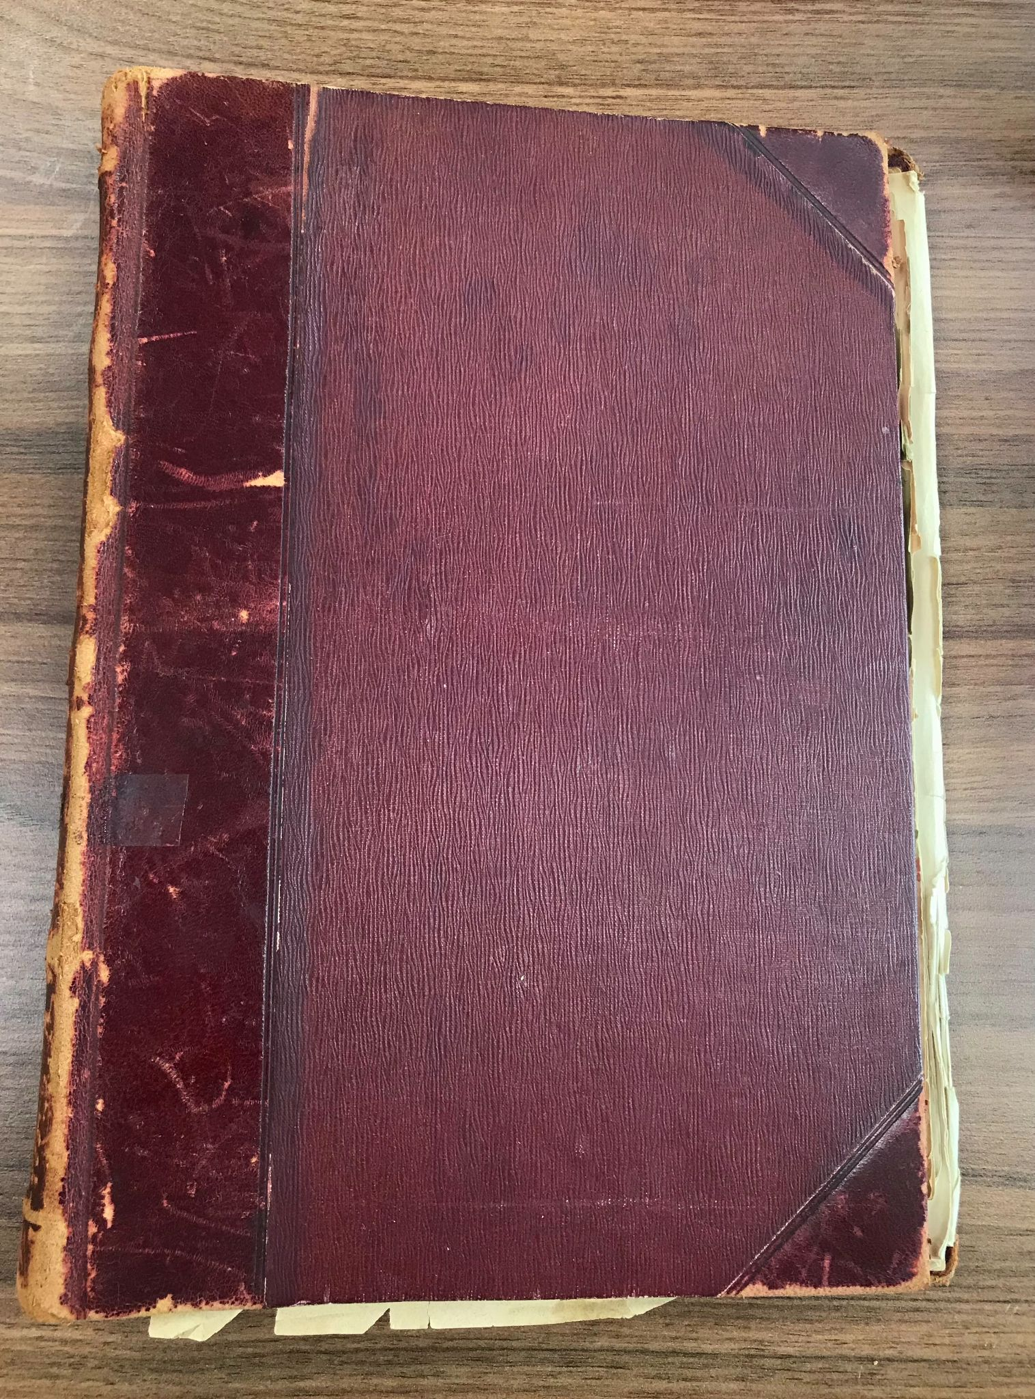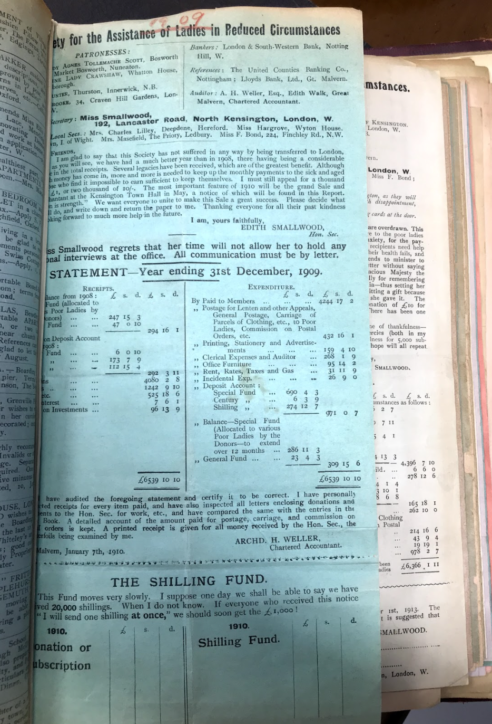

Names from the annual reports were identified from: The ‘Special Subscriptions and Donations’ section (larger gifts of £50-250), ‘Legacies’, and the named ‘Patronesses’ of the charity. Names from legacies were noted if the legacy amount exceeded £1000.

Having searched almost 50 names, we have isolated the below as direct associations with the charity and its funds. Naturally, among those 50 names there are individuals and organisations who, if traced back far enough, are indirectly associated with a controversial history.

Such connections are inevitable in the context that Great Britain, as a historic colonial power, has countless links to the slave trade and other systems of global oppression. In light of this, the connections discussed below are either direct to the charity or linked by one degree of separation.

Summary of Findings on Investment Origins and Links to Colonial Practice
We began by researching Edith Smallwood and her family, and any associations they may have had with colonialism. Edith was the daughter of a banker, Edward Smallwood, and her mother was a woman called Eliza Jane Wright. Although Edith grew up with servants in the house, her family otherwise came from relatively 'ordinary' origins. Edward's father was a yeoman (a farmer) and Eliza's an architect who did local work in Manchester.

Edward Smallwood worked for the York City and County Banking Company – he died in 1875 and while he was general manager the bank 'serviced the agricultural communities and market towns of Yorkshire's North and East Ridings'. It was only after he died that the bank moved 'for the first time into an investing rather than saving area'. So possible financial connections that this bank could have had to colonialism are very unlikely.

After an assessment of the Smallwood archive, our team identified one key association that needs to be flagged – the East Indian Railway Company. The charity’s links with this company can be seen in the wider context of its, and its donors’, association with the colonial systems that existed across the world at the time.

The East Indian Railway Company and Colonialism

Smallwood’s Link
As displayed in the financial statements of the annual reports, from 1915 Smallwood received interest on investments in the East Indian Railway Company (referred to hereafter as EIRC). In 1915 it purchased £1000 stock (approx. £58,992 today) with 4.5% interest (Figure 2) and received half a year’s interest that year. From 1916 onwards it received a full year’s interest each year, until the charity stopped receiving interest on these investments in 1936 (Figure 3). Over this period the interest fluctuated between 4% and 4.5%.

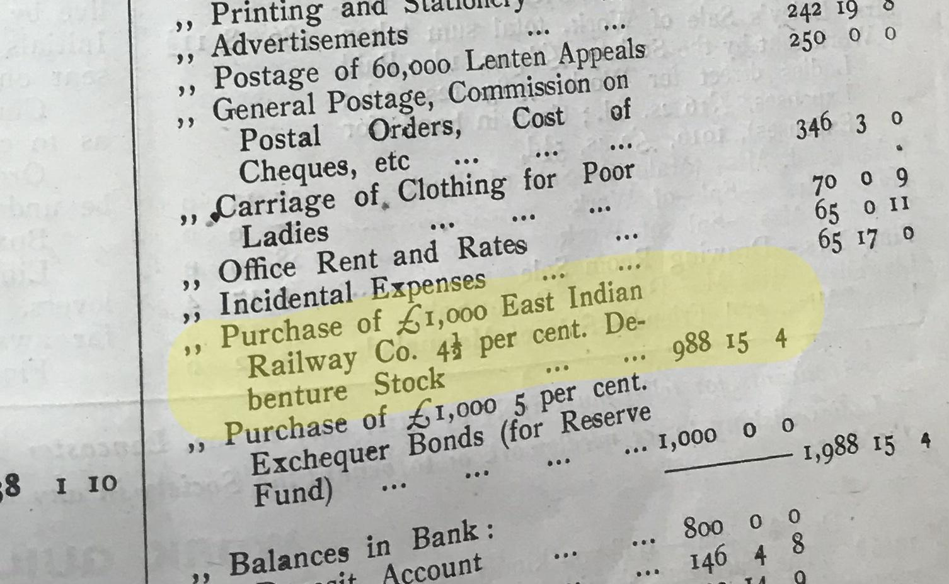
Figure 2: Expenditure for 1915, including the purchase £1000 East Indian Railway Company Debenture Stock, from Trust Annual Report

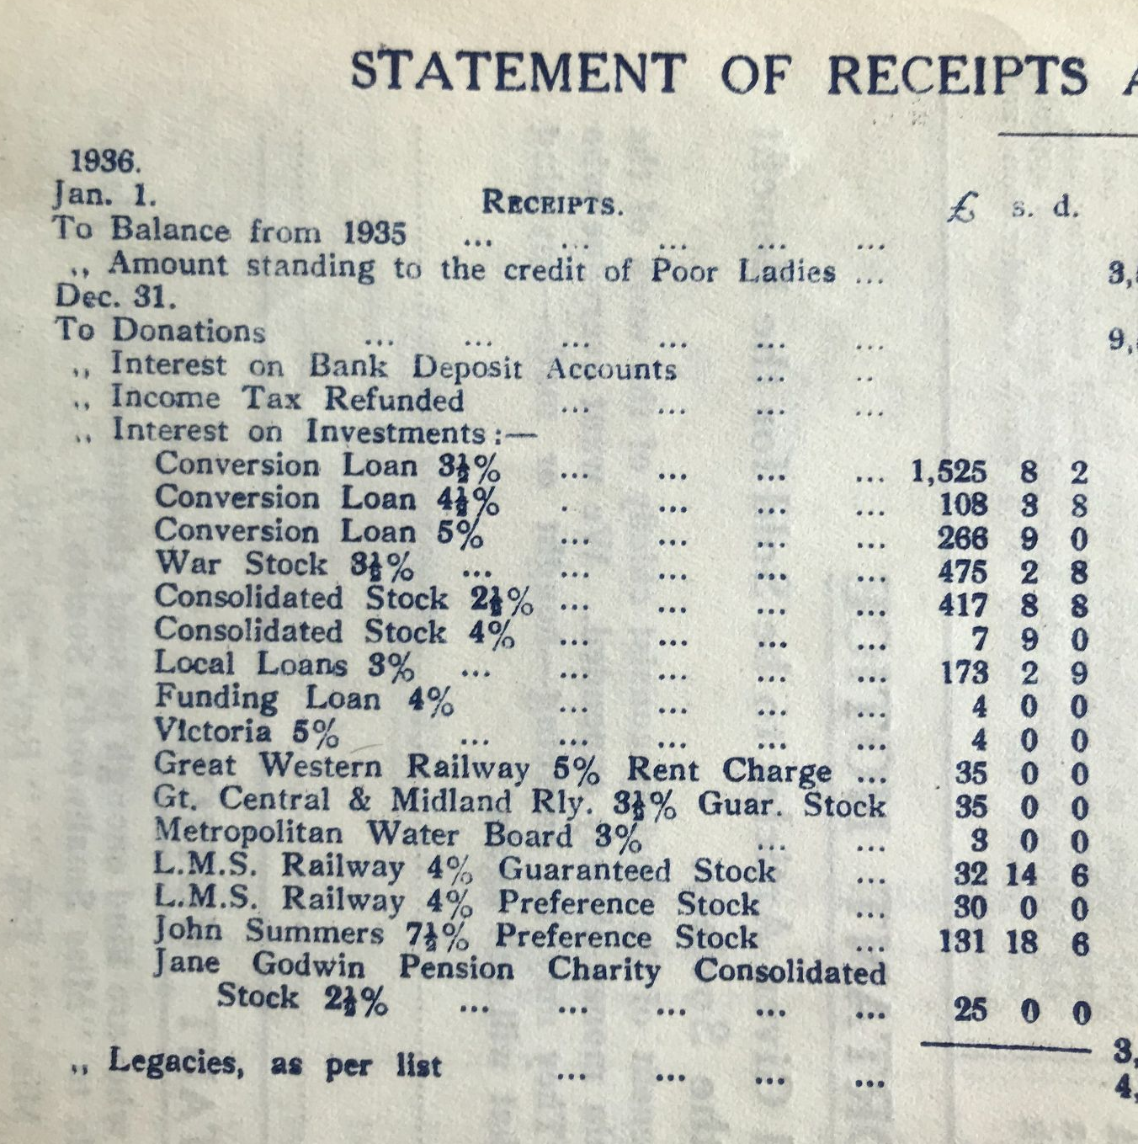
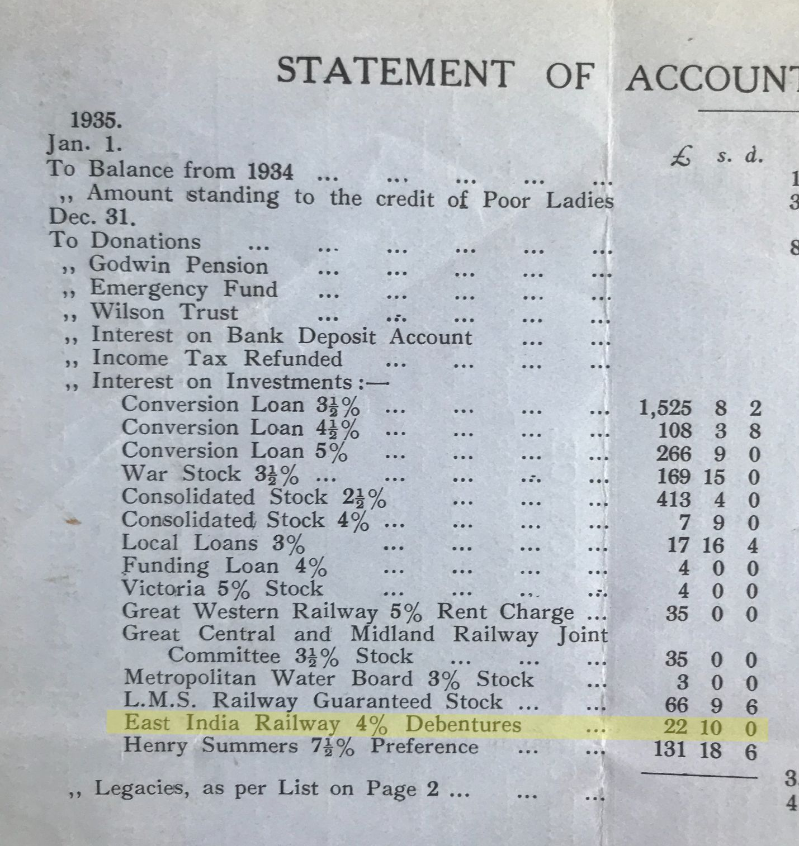
Figure 3: Financial statements for 1935 (left) and 1936 (right) showing the cessation of interest on investment from the EIRC, from Trust Annual Reports

Between 1915-1935, Smallwood received an estimated total of £874. 2s. 6d (approx. £36,800 today) in interest on their EIRC stocks.

In 1916, the receipt of interest on investments in the EIRC was £33. 15s. The charity’s total income for that year was just over £10,790. In 1935, the last year in which the charity received interest on these investments, the receipt was £22. 10s out of a total income of £20,584 that year. Based on these figures, interest on investments in the EIRC constituted between 0.1-0.3% of the charity’s income during the years that it held these investments.

Investments in the EIRC were part of a wider book of investments in railway companies. These will have been an important and relatively predictable source of income for the charity to supplement its reliance on donations.

The EIRC ceases to appear in Smallwood’s financial statements in 1936. A 1935 letter found during our archiving process records the redemption of the EIRC stock and the reinvestment of the money in ‘3.5% Local Loans’.

Historical Significance
While Smallwood had relatively small investments in the EIRC, according to the scope of this report it is important to highlight the historical context of how the EIRC relates to colonialism on a wider scale.

Colonialism, defined as “a policy or system in which a country controls another country or area”, was the foundation of the development of the British Empire from as early as the 16th century. Post-colonial history details the atrocities associated with the imposition of colonial systems, including but not limited to the exploitation of natural resources, looting, destruction of cultural artefacts, the use of concentration camps, and, of course, the slave trade.

The British Empire’s relationship with India goes back as far as 1600, when the East India Company was founded and given a monopoly of all English trade to Asia. By the 1750s, this trading presence developed into waging war on land, and into the early 1800s the British used military dominance to conquer and subdue Indian states. The East India Company was the authority of this colonial process – it assumed administrative roles and exerted military power in the areas it ruled.

Importantly, the East Indian Railway Company (EIRC) in which Smallwood had investments is not the same body as the East India Company, but the two were inextricably linked.
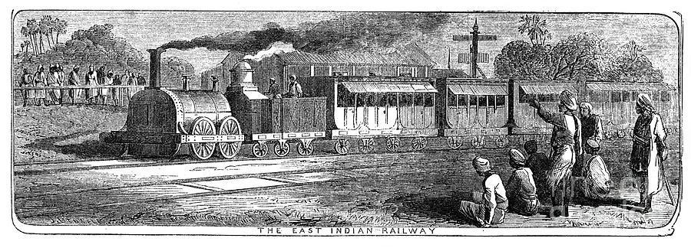
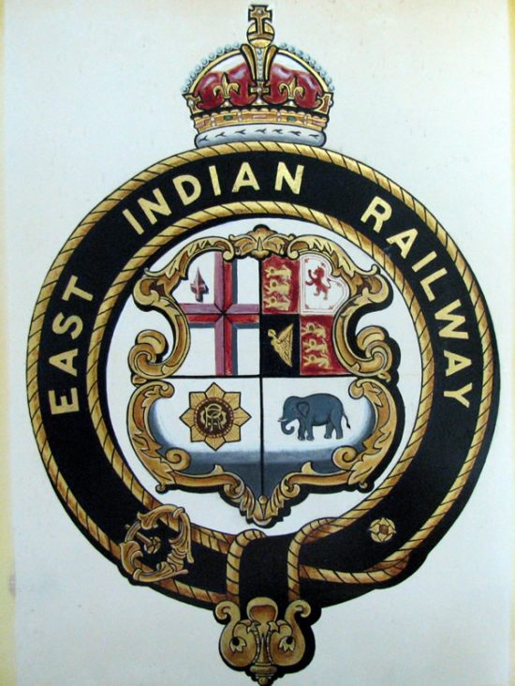
The EIRC was founded in 1845, and its governance, direction and focus were dictated by the East India Company. Its purpose was to build and operate railways lines in the north and east of India and was designed and used as a tool of empire. That is:

- Designed for military and practical administration of the British Empire.

Details from the full contract signed with the East India Company when the EIRC was created (Figure 4) show just how connected the two companies were. By extension they show the extent to which the EIRC operated to further the colonial project.

Figure 4: Details from the contract between the EIRC and the East India Company, 1849

“(1) That the East Indian Railway Company should pay into the Treasury of the East India Company, £1,000,000.
(2) That the East India Company should select the route and direction of a line of railway to be constructed as an experimental line: such line to commence at Calcutta or within 10 miles of Calcutta [...]
(3) That the East India Company should provide the land required for the railway and for stations, offices and so forth.
[...]
(5) That the Railway Company should provide a good and sufficient working stock [...] and allow the use of the railway to the public on terms to be approved by the East India Company, and charge such fares as should be approved by the East India Company.
(6) That the Railway Company, its officers and servants, accounts and affairs be subject to the control and superintendence of the East India Company”

In keeping with the extraordinary amount of oversight the East India Company had into the EIRC, the EIRC was a political project from its inception.

In Figure 4 the East India Company places an emphasis on lines surrounding Calcutta as this was the British capital of India at the time, and such lines were said to “possess political advantages of the highest order”. Lord Henry Hardinge, Governor-General of India between 1844 and 1848, argued that the EIRC’s construction of rail lines would be beneficial ‘to the commerce, government and military control of the country’.

- Designed to extract resources from India, not to benefit Indian society or economy.
Railway lines were planned to transport extracted resources from India’s interior to British ports. The classic example of this exploitative design was cotton: Indian raw cotton was transported to the UK where it was made into textiles that were then transported back to the Indian market, undercutting the indigenous industry that had once thrived.

- Initially only hired white Europeans, and actively excluded Indians from the workforce.
Indians were not initially employed by the EIRC. At every level – signalmen, repairmen, directors and even ticket-collectors – only white Europeans were hired (and paid at European, not Indian, rates). In 1912, having discovered that Indian mechanics were designing and building their own trains at a cheaper cost, the British passed an act preventing these workshops from designing and manufacturing trains. Even in the early 20th century all “key employees” were white men.

Over time Indians did become a part of the EIRC workforce (as evidenced by the existence of two labour unions for EIRC Indian workers) and in 1922 these workers went on strike, demanding: “a pay increase, housing allowance [...] publication of previous cases of racially motivated violence [between Indian and European workers] on the railway, and the prevention of future violence”.

- Indian passengers were unprioritised and discriminated against.
Many early proponents of the railway believed Indians would not use them and the benefit to Indians was never prioritised. It wasn’t until 1897 that third class passengers were admitted to the mail trains and not until 1905 that express trains were first run for “lower class” passengers. In each case Indians travelled in these lower classes. Third class compartments (when they did exist) were dreadful, with wooden benches and zero amenities.

The East India Company was nationalised in 1858 when the British Crown (Queen Victoria) took over formal control of India, and the British Raj (1858-1947) began. In 1879, the EIRC was also nationalised but operated independently of the British Indian Government. Later in 1925, the British Indian government took over the management of the EIRC.

As discussed above, Smallwood’s investments in the EIRC span from 1915-1935. This time span covers periods when the EIRC operated independently of the British government, as well as when it was managed by the British government. Importantly, it was a function of British rule in India throughout.

Crucially, interest on Indian colonial stock, such as the EIRC stock held by Smallwood, was raised by the British government from Indian taxpayers. As just one example of the source of such taxes, the British tax on salt was the inspiration for Gandhi’s famous “salt march” in 1930.

British rule in India ended in 1947, twelve years after Smallwood redeemed and reinvested its EIRC debenture stock.

To reiterate, Smallwood’s 1915-1935 stocks in the EIRC were the only direct association to controversial historical events that our team found after investigation within our research parameters. There were, for example, no evident direct links to slavery.

However, evidence of Smallwood’s functioning in a world where colonialism existed at large in India and across the world was also found in the below examples, which link the charity to colonialism by one degree of separation.

Other Colonial Connections

Legacies
Two examples of colonial investments similar to the stocks held by Smallwood were found in the Legacies Invested folder from 1931-36.

In 1932, L. E. C. Jennings-Bramley died and left a legacy of £1098 to the charity. She herself had purchased £5000 worth of EIRC stock, and the proceeds from its sale were part of her estate when she died.

In 1931, Alice French left a legacy of £5055. Details of her estate show that she had a number of investments in ‘colonial railways’ and ‘foreign railways’.

The Tweedsmuirs
The charity has had connections to the Tweedsmuir family from the 1940s through to the 1980s. In 1946, Susan Buchan, Lady Tweedsmuir, became a patron to the charity, and was still a patron in 1964 according to the latest available annual report held in the archive before her death in 1977. Smallwood beneficiaries were also employed by Lady Tweedsmuir to create scrapbooks of her and her husband’s media appearances.

Lady Tweedsmuir was the widow of John Buchan, 1st Baron Tweedsmuir. He died in 1940, but over his lifetime had various connections to colonialism. In his early career (c. 1901) he was private secretary to the administrator of a number of colonies in southern Africa, and from 1935-1940 he was Governor General of Canada (a country that was subject to British rule until 1982).

The physical archive holds records of correspondence with the Tweedsmuir family in the 1980s, at which time the Lord Tweedsmuir was John’s son Johnnie Buchan. He served in the Colonial Administrative Service in Uganda in the 1930s.

The above connections to colonial infrastructure are representative of the fact that Smallwood’s donors and patrons, so often the moneyed and influential in Britain, were naturally connected to the means by which Britain as a nation maintained its wealth and power. Smallwood itself became connected to those means when building its investment portfolio. And at the time, Britain’s wealth and power was still in part being derived from colonial practices.

P: p. 9, Shelf 5; D: p. 2, Legacies, Investments, Financial
P: p. 10, Main Table; D: p. 11
Approx. £1,500-7,200 today (based on the year 1920). This and all following currency conversions use National Archives Currency Converter https://www.nationalarchives.gov.uk/currency-converter/
Approx. £30,000 today (based on the year 1920).
https://leicester.figshare.com/articles/thesis/Provincial_banking_in_nineteenth_century_England_York_City_and_Country_Banking_Co_1830-1880_/10188215
This figure is the sum of EIRC interest recieved every year between 1915-1935, adjusted to reflect how much the interest would have been worth in that year. Because of changes to the formatting of the annual reports in 1919/1920, we do not have the exact figures from these years, so it has been assumed that the interest received was £45 in each of those years – as it was from 1918-1934.
Approx. £1,991 today
Approx. £636,526 today
Approx. £1,139 today
Approx. £1,042,839 today
https://drive.google.com/file/d/1iaMD0819uRTcTXMA3E6pXglueIIsJ18t/view?usp=sharing
https://dictionary.cambridge.org/dictionary/english/colonialism
https://www.theguardian.com/commentisfree/2017/nov/22/british-empire-museum-colonial-crimes-memorial
http://www.bbc.co.uk/history/british/empire_seapower/east_india_01.shtml
https://archive.org/details/in.ernet.dli.2015.506696/page/n11/mode/2up pp. 7-8
https://archive.org/details/in.ernet.dli.2015.506696/page/n11/mode/2up p. 1
https://www.theguardian.com/world/2017/mar/08/india-britain-empire-railways-myths-gifts
McDonough, Frank, The British Empire, 1815-1914
https://www.theguardian.com/world/2017/mar/08/india-britain-empire-railways-myths-gifts
https://journals.sagepub.com/doi/abs/10.1177/0019464613515554
https://archive.org/details/in.ernet.dli.2015.506696/page/n11/mode/2up Chapter 1
https://www.theguardian.com/world/2017/mar/08/india-britain-empire-railways-myths-gifts
Approx. £50,272 today
Approx. £228,927 today
Approx. £231,445 today
P: p. 10, Floor by safe

